28.03.2020 Специальность ОП
Курс 3 группа ОП 179-2
Дисциплина иностранный язык
Фио преподавателя Ситдикова Наиля Гайфетдиновна
Тема 3.2. Автотранспортное предприятие. Фразовые глаголы
Содержание учебного материала
Задание 1. Зааписат слова и выучить Mind the words
To propose – предлагать High density – высокая плотность
Layout – расположение Improvement – улучшение
To cause – вызывать, быть причиной Transport mode – вид транспорта
To gather – собираться To broaden – расширять
Mutual – взаимный Residential - жилой
Urban – городской road congestion – затор на дороге
Rural – сельский to install – устанавливать
To remain – оставаться acceptable – приемлемый
To enlarge – увеличивать existing – существующий
Distribution – распределение interchange – развязка
Movement – движение

Задание 2 . письменно перевести словосочетания на русский язык. Translate word combinations
To propose a project; layout of the city, favorable layout of the city; to cause the growth of population; to gather for mutual protection; urban population, urban transport; rural population; to remain the same; to enlarge the movement; distribution of urban population, movement of population, high density center; improvement of situation, improvement of urban transport; major transport mode; to broaden the territory; residential areas; road congestion leads to, to cause road congestion; acceptable transport mode; existing transport system; to build road junctions.
Задание 3. Прочитайте и письменно переведите текст на русский язык. Read and translate the text.
City and City Transport

The problem of urban transportation has become very important. A large number of new transport systems is known to have been proposed in the past decade or so.
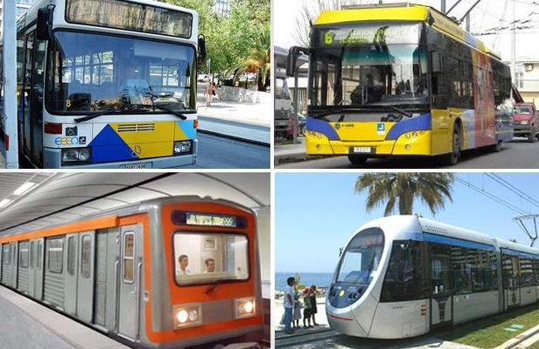
But before describing the new systems and their applications it is necessary to look back briefly to see how cities got their present layout, and what are the factors that have caused the present problems of urban transport.
The first factor is the growth of population. The cities developed as a rule because of the need for people to gather for mutual protection, for commerce and for education. In England since 1801 the rural population remained almost constant, while urban population has grown by than twenty times. The population growth has greatly enlarged the movement of passengers in big cities.
The second factor is the changing distribution of population within cities. There has been a steady movement of population from the high density center to the lower density suburbs. The increase and improvements of transport are believed to be the main reasons for this movement.
Walking was the major transport mode both in and out of cities until the end of the 18th century. The cost of a horse in terms of a laborer’s wages was about three times that of a mass produced motor car today.
This lack of cheap transport led to the development of very high density building within the city center. The situation was changed with the introduction of horse buses and urban railways in the middle of the 19th century, followed by the horse trams and electric trams towards the end of that century.
The introduction of the motor car and motor bus in the 1920s allowed the residential areas along the railways lines to broaden and the increase of car ownership since about 1950 has led to both residential and industrial development in open areas around cities. This growth leads to longer journeys to work, school, or shopping, and more travel per day, even without population growth.
The third factor is the growth of private cars. To own a car had become not only pleasant, but in many cases simply necessary. However, car ownership leads to road congestion. The congestion is partly a result of the rush-hours during travel to and from work and school.
Of course, transport is only a service industry, and must be coordinated with developments in communications and with planning. The first thing to do is to develop transport systems which are cheaper to install, cheaper to operate and aesthetically more acceptable than some of the existing ones.
To solve the problem of traffic jams in cities the underground railways are built, local authorities develop the road system building network of interchanges trying to control road traffic.
Ззадание 4. Напишите способы решения загруженности дорог в Казани. Offer your ways of solving the problem of congestion in Kazan. Use the following word combinations.
I agree/disagree, from my point of view, on the one hand …, on the other hand…, to tell the truth, on the contrary ….
Контрольные вопросы. Ответить на вопросы письменно
- What transport problem has become very important?
- What are the factors that have led to the present day problems of urban transport?
- What was the major transport mode until the end of the 18th century?
- What led to the development of very high density building within the city center?
- What kinds of changes were made in the middle of the 19th century?
- What does car ownership lead to?
- What must transport be coordinated with?
- What is made to solve the problem of traffic jams?

Список литературы электронное пособие Ситдиковой НГ и Файзрахмановой ЮС “Professinal English for Students of Logistics”
Примечание:
Письменно сдать в электронном формате 28.03.2020 до 17.00 на электронную почту sit_nelya@mail.ru
задания желательно присылать в электронном виде, прикрепив отдельным файлом и указав дату проведения занятия, каждый листок подписываем отдельно указав ФИО, номер группы и тему занятия.

Например
25.03.2020 (дата проведения занятия), ТМ 199-1, Иванов Иван Иванович T.3.3 What are you doing now?

--с уважением Ваш преподаватель английского языка
Ситдикова НГ 27.03.2020

