Курс:_______I_I____, группа(ы)______ AМ 189______________________
Дисциплина:________Иностранный яз._______________________________
ФИО преподавателя_____Шафигуллина И.Ш._______________________
Тема: Принцип работы 4-х тактного двигателя .Сослагательное наклонение.

Text: Principle of Operation of the
Four-Stroke Petrol Engine

The exercises to be done before reading the text
Предтекстовые упражнения
Упражнение 1. Прочтите слова и словосочетания и запомните их русские эквиваленты.
bottom dead center - нижняя мертвая точка
charge of fuel — заряд топлива
combustion — сгорание
combustion chamber – камера сгорания
compression stroke — такт сжатия(смеси)
connecting rod - шатун
crankshaft — коленчатый вал
cylinder - цилиндр
diesel engine — дизельный двигатель
engine — двигатель
exhaust stroke — такт выпуска
four-stroke cycle — четырехтактный цикл
fuel injection — впрыск топлива
ignite — воспламенять
ignition — воспламенение
intake (inlet) stroke — такт впуска
internal combustion engine – двигатель внутреннего сгорания
mixture — смесь
operating cycle - рабочий цикл
petrol engine — бензиновый двигатель
piston — поршень
power stroke — рабочий ход
pressure - давление
reciprocating movement — возвратно-поступательное движение residual gas — остаточный газ
rotary movement — вращательное движение
spark plug — свеча зажигания
stroke — ход (поршня);
top dead center — верхняя мертвая точка
valve - клапан

Упражнение 2. Переведите слова на русский язык, обращая внимание на суффиксы.
to combust — combustion; to operate — operation; to ignite — ignition; to reciprocate — reciprocation; to connect — connection; to compress — compression; to describe — description.
Упражнение 3. Прочтите и переведите интернациональные слова.
Principle, cycle, piston, center, cylinder, atmosphere.
Упражнение 4. Переведите предложения на русский язык, используя терминологию упражнения 1.
- During the inlet (intake) stroke the inlet valve opens and a charge of fuel (mixture) flows into the cylinder.
- During the compression stroke the inlet valve is closed and the fuel is compressed by the rising piston.
- During the power stroke both valves are closed, pressure rises in the combustion chamber, and the spark ignites the mixture.
- During the exhaust stroke the exhaust valve is opened, pressure is released and the residual gases flow into the atmosphere through the exhaust valve.
Прочтите и переведите текст, а затем выполните следующие за ним упражнения.
TEXT

Principle of Operation of the Four-Stroke Petrol Engine
The internal combustion engine is called so because fuel is burned directly inside the engine itself. Most automobile engines work on a 4-stroke cycle. A cycle is one complete sequence of 4 strokes of the piston in the cylinder. The operating cycle of the four-stroke petrol engine includes: inlet stroke (intake valve opens), compression stroke (both valves closed), power stroke (both valves closed), exhaust stroke (exhaust valve is opened).
To describe the complete cycle, let's assume that the piston is at the top of the stroke (top dead center) and the inlet and the exhaust valves are closed. When the piston moves down the inlet valve opens to intake a charge of fuel into the cylinder. This is called the inlet (intake) stroke. On reaching the lowest position (bottom dead center) the piston begins to move upward into the closed upper part on the cylinder, (he inlet valve is closed and the mixture is compressed by the rising piston. This is called the compression stroke. As the piston again reaches the top dead center the spark plugs ignite the mixture, both valves being closed during its combustion. As a result of burning mixtures the both valves being closed during its combustion. As a result of burning mixtures the gases expand and great pressure makes the piston move back down the cylinder. This stroke is called the power stroke. When the piston reaches the bottom of its stroke, the exhaust valve is opened, pressure is released, and the piston again rises. It lets the burnt gas flow through the exhaust valve into the atmosphere. This is called the exhaust stroke which completes the cycle. So the piston moves in the cylinder down (intake stroke), up (compression stroke), down (power stroke), up (exhaust stroke).
The heat released by the fuel is transformed into work so that the reciprocating movement of the pistons is converted into rotary movement of a crankshaft by means of connecting rods.
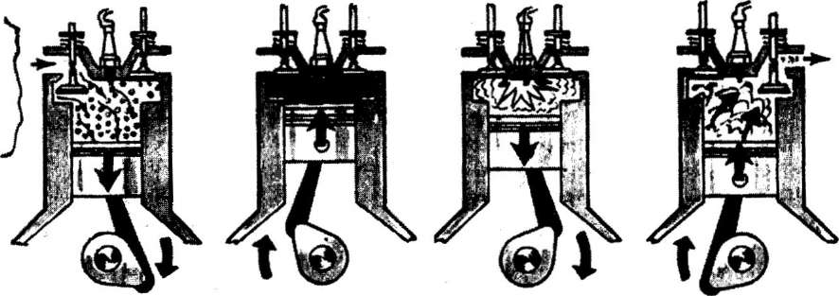
1 - intake 2 - compression 3 - power 4 - exhaust
Рис. 1. Principle of Operation of the Four-Stroke Petrol Engine

- intake - такт впуска 3. power — рабочий такт
- compression — такт сжатия 4. exhaust — такт выхлопа

The exercises to be done after reading the text

Послетекстовые упражнения
Упражнение 5. Найдите в тексте абзацы, где идет речь о такте впуска, о такте сжатия, о рабочем ходе, о такте выпуска и переведите их на русский язык.
Упражнение 6. Выберите правильные по смыслу ответы на вопросы.
1. Why is the engine called the internal combustion engine?
2. What stroke is called the inlet one?
3. What is a compression stroke?
4. What takes place in the cylinder on power stroke?
5. What takes place on the exhaust stroke?
6. By means of what is the reciprocating movement of the pistons converted into rotary movement of a crankshaft?
1.It is called so because the fuel (the mixture) is burned…
a)directly inside the engine;
b)outside the engine.
2. The inlet stroke is called so because during moving down the piston…
a) the inlet valve opens to intake a charge of fuel into the cylinder;
b)the inlet valve is closed and the mixture is compressed.
3.The compression stroke is a stroke
a) when the inlet valve opens to intake a charge of fuel into the cylinder;
b) when the inlet valve is closed and the mixture is compressed.
4. On power stroke
a)the spark plugs ignite the mixture, both valves are closed during its combustion;
b)the exhaust valve is opened and the residual gas flows through the exhaust valve into the atmosphere.
5.On the exhaust stroke
a)the spark plugs ignite the mixture, both valves are closed during its combustion;
b)the exhaust valve is opened and the residual gas flows through the exhaust valve into the atmosphere.
6. It is done
a)by means of pistons;
b)by means of the connecting rods.
Грамматический материал. Изучить грам.материал,сделать конспект .
Формы наклонения

Наклонение | Действие | Пример | Перевод
Изъявительное | Выражает реальное действие в настоящем, прошедшем и будущем. | Не goes to the office every day. | Он ходит в офис ежедневно.
Повелительное | Выражает приказание, просьбу; побуждает к действию. | Come up to me. Open the window,  please.  Let's go to the cinema. Don't go there. | Подойди ко мне! Открой окно, пожалуйста.  Давайте пойдем в  кино.  Не ходите туда.
Сослагательное | Выражает допустимость, возможность совершения действия (в настоящем или будущем). | If I knew him better, I should give him advice.  I suggested that we should go to the country tomorrow. I wish you were present at the conference today. | Если бы я знал его лучше, я дал бы ему  совет.  Я предложил, чтобы мы поехали за город завтра.  Я хотел бы, чтобы вы присутствовали сегодня на конференции.
 | Выражает нереальность, невозможность совершения действия (в прошлом). | If I had known him better, I should have  given him advice.  I wish you had been present at the conference yesterday. | Если бы я знал его лучше, я дал бы ему совет. (Я его не знал, совета не дал). Я хотел бы, чтобы вы вчера присутствовали на конференции. (Жаль, что вы не присутствовали.)

Домашнее задание. Учить слова по теме « Принцип работы 4х тактного двигателя. Составить 10 предложений ,употребляя сослагательное наклонение.

Литература :

1. В.А. Шляхова. Английский язык для студентов автомобилестроительных специальностей. Учебное пособие. – М.: «Высшая школа», 2014. - 120 с.
2. Англо-русский словарь основных транспортных терминов [Электронный ресурс] / Под. общ. ред. В.В.Космина. – М.: РИОР: ИНФРА-М, 2013. – 544 с. – (Б-ка малых словарей ИНФРА-М)
3. Маньковская З.В. Английский язык : учеб. пособие / З.В.Маньковская. – М.: ИНФРА-М, 2018. – 200 с. – (Среднее профессиональное образование)

Домашнее задание надо оправить на электронную почту ilsiyar.shafigullina@mail.ru до 25.03.2020 до 15.00

