Специальность: Техническое обслуживание и ремонт автомобильного транспорта.

Курс: 2. Группа: ТМ 189-2.

Дисциплина: Иностранный язык.

Преподаватель: Сорокина Р.Ш.

Дата: 24.03.2020.

Тема: Автомобильное производство. Времена Indefinite Passive.

**1. Прочтите и переведите текст, а затем выполните следующие за ним упражнения.**

**TEXT**

**Automobile Production**

I study at the college, at the automobile-construction department. When I graduate from the college I shall become a technician. All spe­cialists in automobile industry dealing with manufacturing automo­biles (cars or trucks) must know that the production of the automobile comprises the following phases:

* 1. -designing;
  2. -working out the technology of manufacturing processes;
  3. -laboratory tests;
  4. -road tests;
  5. -mass manufacturing (production).

Why is it necessary to know all these facts? It is important to know them, as before the automobile is put into mass production it should be properly designed and the car must meet up-to-date requirements. What are these requirements?

The automobile must have high efficiency, long service life, driv­ing safety, ease of handling and maintenance, pleasant apperance. Also it must be comfortable and ecological. In order to obtain these quali­ties the specialists should develop up-to-date methods of designing cars using new types of resistant to corrosion light materials. Also it is im­portant to know computer sciences because computers offer quick and optimal solutions of the problems. Besides they are used for better op­eration of mechanisms in cars.

Before the car is put into mass production the units of the car are subjected to tests in the Works laboratory and then the car undergoes a rigid quality control in road tests. Why are these tests required? What qualities are required of the automobile? They are needed because the modern automobile must be rapid in acceleration, have smooth acting clutch, silent gearbox, dependable braking and steering systems, de­pendable ignition system, low fuel consumption and be stable on the road.

**Послетекстовые упражнения**

Упражнение 1. Найдите и выпишите из текста слова, относящиеся:

а) к производству автомобиля;

б) к характеристикам автомобиля. Дайте их русские эквиваленты.

Упражнение 2. Найдите в тексте ответы на вопросы:

1.What department do you study at?

2.What will you become after graduating from the college?

3.What should automobile specialists know?

4.What phases does the production of the automobile comprise?

5.What requirements must modern automobiles meet?

6.Why are automobile units and mechanisms subjected to labo­ratory and road tests?

7.What qualities are required of the automobile?

8.Why are computers used in cars?

Упражнение 3. Ответьте на вопросы.

* 1. 1.What college do you study at?
  2. 2.What will you become after graduating from the college?
  3. 3.What will you deal with?
  4. 4.What phases does the production of the automobile comprise?
  5. 5.Why are the cars subjected to laboratory and road tests?
  6. 6.What qualities must the car have?
  7. 7.What units must the car have?

Упражнение 4. Составьте рассказ о вашей будущей профессии, используя упражнение 3 в качестве плана.

**2. Изучите грамматический материал, выполните упражнения на закрепление.**



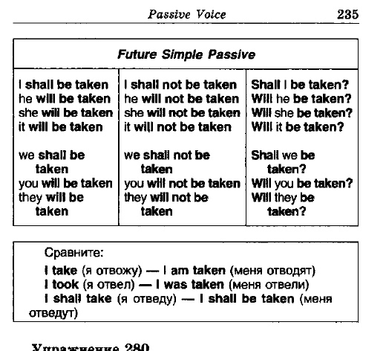



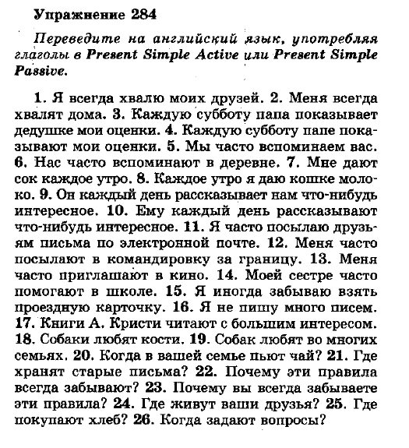

**Отчёт по выполнению прислать на указанный адрес эл.почты (послетекстовые упражнения**

**1-4, грамматические упражнения 282, 284).**

Срок выполнения задания: 29.03.2020.

Форма выполнения: документ Microsoft Word, шрифт 12, интервал 1; либо фото рукописных записей в доступной для восприятия форме. *Обязательно подписать группу и Ф.И.О. выполнившего!*

Электронная почта преподавателя: **redgie1@yandex.ru.**