Курс:_______I_____, группа(ы)______ ТОД 199______________________
Дисциплина:________Иностранный яз._______________________________
ФИО преподавателя_____Шафигуллина И.Ш._______________________
Тема: Олимпийское движение .Зимняя олимпиада в Сочи 2014. Закрепление грам. материала.
Задание 1. Прочитать и письменно перевести текст .Составить 4-5 вопросов на английском языке к этому тексту.
Olympic Games In Sochi 2014
There are many interesting and exciting events in our life, which help us to become better and to strive for self-culture. The Olympic Games are one of them. They have existed since ancient times and still remain the main event in the sporting life of our planet.
The official motto of the Games is the Latin phrase “Citius, Altius, Fortius”, which means “Faster, Higher, Stronger”. The father of modern Olympic competition, Pierre de Coubertin, suggested this slogan. Since late 19th century every four years the whole world is thrilled to watch the Summer and Winter Games featuring the best athletes from different countries.
I’m proud to say that 2014 Winter Olympics were held in Sochi. It’s one of the most beautiful Russian cities on the Black Sea coast. In July 2007 the International Olympic Committee held a conference in Guatemala, during which Sochi was chosen to host the 22nd Winter Olympic Games.
More than 80 countries took part in this event. Some of the disciplines involved half-pipe skiing, mixed-team figure skating, biathlon mixed relay. Several new venues were built for these events, among them the Ice Cube Curling Center, the Shayba Arena, the Fischt Olympic Stadium. Apart from venues, there were a couple of spacious Olympic villages and the International broadcasting center.
The official mascots of the event were a polar bear, a snow leopard and a hare. Being situated in subtropical zone, Sochi was declared to be the warmest city for Winter Olympics. The opening ceremony of the event took place on February 7th, 2014, and was said to be one of the most spectacular and impressive shows.
The atmosphere during the Games was exciting. There were 98 events over 15 disciplines in 7 sports.
According to the medal table Russian athletes won the highest number of medals. In total, they brought home 33 medals, including remarkable 13 golds.
The closing ceremony took place at the Olympic Stadium on February 23, 2014. It was dedicated to Russian culture, music and arts.
Задание 13 ( из учебника) соотнести слова с их значениями (пишем словами).
Задание 14.(из учебника) построить предложения в разных временах , используя слова в скобочках.
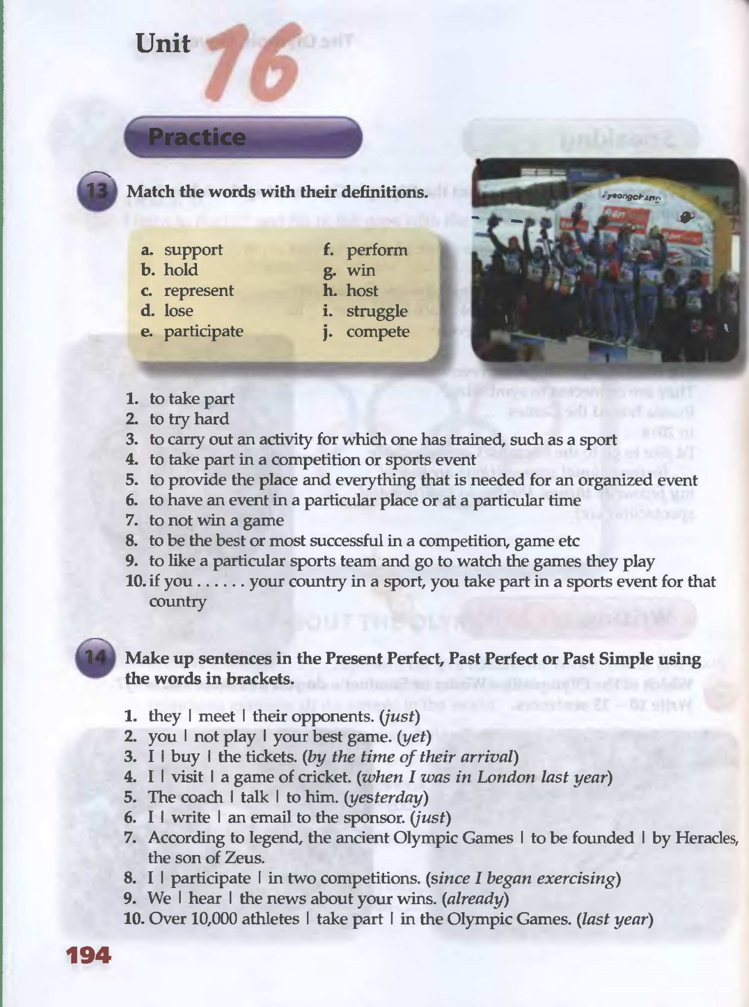
Выполнить тест на употребление Present Perfect.Выбрать правильный вариант ответа.Можно (цифра ,буква)
1 I ___ my best friend for ten years.
A have known B knew C has known
2 Somebody ___ our car last Sunday.
A stole B has stolen C have stolen
3 I don’t want to go to the cinema. I ___ this film.
A has already seen B have already seen C already saw
4 Is Mary at home? No, she ___.
A has just left B have just left C just left
5 My brother ___ a lot when he was young.
A has swum B have swum C swam
6 Michael ___ to play the piano last year.
A has learnt B have learnt C learned
7 Do you want something to drink? No, thanks. I ___ a cup of tea.
A just had B have just had C has just had
8 My parents ___ to Germany in 2005.
A went B has gone C have gone
9 Sally ___ her relatives for a very long time.
A haven’t seen B didn’t see C hasn’t seen
10 I ___ this college since September.
A have attended B has attended C attended
Домашнее задание .Подготовить небольшое сообщение о знаменитом спортсмене( спортсменке) на англ.яз. с переводом.
Литература :
1. Безкоровайная Г.Т., Койранская Е.А., Соколова Н.И., Лаврик Г.В.PlanetofEnglish: электронный учебно-методический комплекс английского языка для учреждений СПО. - М., 2015
2. Маньковская З.В. Английский язык : учеб. пособие / З.В.Маньковская. – М.: ИНФРА-М, 2018. – 200 с. – (Среднее профессиональное образование) // Режим доступа: znanium.com
Домашнее задание отправлять на электр.почту ilsiyar.shafigullina@mail.ru до 25.03.2020. до 15.00.

