Курс:____II_______, группа МР 189
Дисциплина Иностранный язык
Дата 24.03.2020 (2 занятия)
ФИО преподавателя Файзрахманова Ю.С.
Сдать в электронном формате до 25.03 на электронную почту julia_amira@mail.ru
Литература: Электронный учебник Маньковская, З. В. Английский язык // режим доступа https://znanium.com
Тема. 1. Преимущества и недостатки работы ДВС. Причастный оборот
1.Прочтите текст 1
2.Найдите в тексте абзац, в котором говорится о конструкции двигателя, запишите перевод.

TEXT 1 Internal Combustion Engines
The first internal combustion engine light enough in weight was the gasoline engine, invented by a German named Otto.
At the same time Dr. Rudolph Diesel was working on the diesel engine. The Diesel engine is similar to the gasoline engine in many ways. There are many variations in engine arrangements, but the basic parts of most 4-stroke cycle engines are similar.
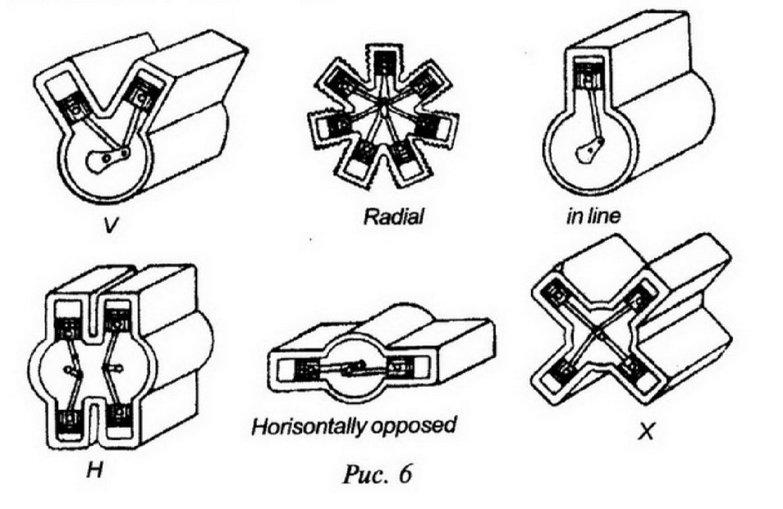
In the in-line arrangement the cylinders are lined up in a single row. The V-type engine is called so as the cylinders form 2 rows or "banks", set at an angle to each other to form the letter V.
The diesel engine gets its power from the expansion of burning gases. The diesel engine depends on the heat of compression for ignition of the fuel.
Liquid fuel that contains more heat energy than gasoline is diesel oil.
Diesel oil is slower burning, but it produces more power. Diesel engines also must be heavier than gasoline engines, but they are more efficient when working under heavy loads at low speeds.
The advantages of the diesel over the gasoline engine are as follows: a).more economic operation;
b).higher compression ratio;
c).reduced maintenance costs;
d).good pulling power.
Прочтите текст 2 и заполните таблицу преимущества бензиновых двигателей, преимущества дизельных двигателей?

TEXT 2 Engines
The two most common types of engines for cars are the petrol engine and diesel engine.
Petrol engines are usually lighter and smaller than diesel engines. This makes them cheaper, and this is why most cars use petrol engines. Petrol engines are also less noisy than diesel engines. They usually go foster. On the other hand, diesel engines use less fuel than petrol engines, and this is why trucks use them. They are also safer than petrol engines, because there is less danger of fire.
There are two main types of petrol engine - 4-stroke and 2-stroke. All cars use 4-stroke engines. But most motorbikes use 2-stroke engines. They are lighter and smaller than 4-stroke engines, and are therefore cheaper.
Advantages of petrol engines | Advantages of diesel engines

Повторите грамматический материал по теме Причастный оборот в электронном учебнике Маньковская, З. В. Английский язык // режим доступа https://znanium.com стр. 109
Выполните письменно упражнение 1 стр. 109-110

Тема 2. Альтернативные двигатели.

Прочитайте текст и ответьте письменно на вопросы
1. How are electric cars powered?
2. What do people think of electric cars in your country?
Planetary Motors is proud to introduce its first electric car, The Isotope is an Earth-friendly car that can save you ......... money and reduce your carbon footprint. When you drive the Isotope, there's no need to stop for gas. The onboard charger lets you power up at your home charging dock for less than $2 per charge. Just plug an electric cord into the charging port and you're good to go.
With the Isotope, you can complete your commute to work and errands without needing a drop of gas. Isotope has a range of 100 miles per charge, so there's no need to worry about reaching your destination. And Planetary Motors is developing a network of national charging stations. Soon you will be able to drive and recharge wherever your heart desires.
Most importantly, the Isotope is safe for the environment. Although the Isotope's electric motor provides speeds up to 90 MPH, it doesn't harm our planet. Unlike --·-- conventional cars, the Isotope has zero tail pipe emissions. Even its backup system is eco-friendly. The Isotope's photovoltaic system charges the emergency battery through small solar panels located on the hood. So, what are you waiting for? Come check out the Isotope and see what zero emission driving can be.
Письменно отметьте следующие утверждения как верные (T) или неверные (F).
1. Isotope owners can install a charging dock at home.
2. Planetary Motors recently completed a system of charging stations.
3. The photovoltaic system powers the electric motor.
Сопоставьте слова (1-5) с определениями (A-E). Задание выполняется письменно

1. onboard charger | A. the gases produced by an engine
2. range | B. the distance a car can travel on one charge
3. solar panel | C. a device that changes sunlight into electricity
4. tail pipe emissions | D. a business that provides electricity for cars
5. charging station | E. the device on the that supplies power to the battery

Выполните письменно упражнение 2 стр. 110 в электронном учебнике Маньковская, З. В. Английский язык // режим доступа https://znanium.com

Сдать в электронном формате (если фото, то необходимо архивировать) до 25.03 на электронную почту julia_amira@mail.ru

